**Supply & Demand graph of a Perfectly Competitive (PC) firm selling good A in the Short run**

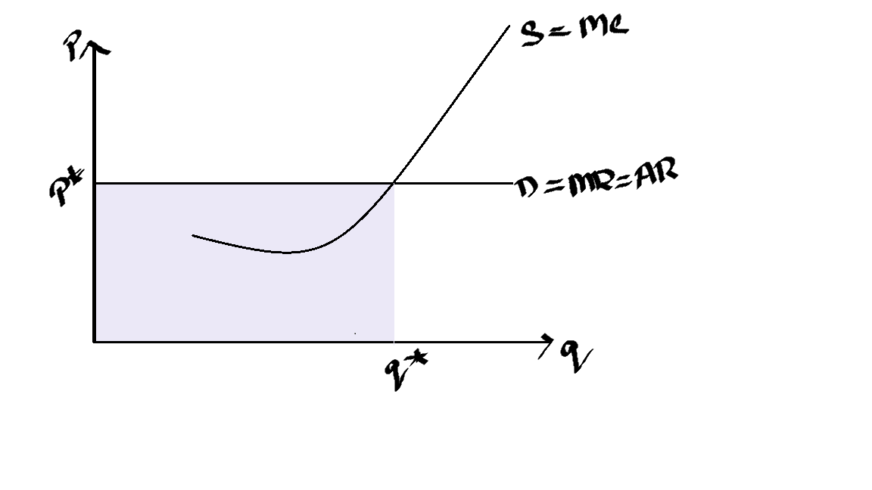

The supply curve is the same as the Marginal cost curve.

The demand curve is the same as the Marginal revenue curve which is also equal to Average revenue.

At what point will a PC firm produce when price is at p*?

The firm will produce at the equilibrium point. At the equilibrium point, MR=MC hence q* is the profit maximizing output when the price is set at p*.

Even if the firm produces at MR=MC, it does not **ALWAYS** indicate that the firm is making maximum profit. To find whether the firm is operating at profit/ loss, we need to look at average cost and then calculate the economic profit/ loss.

In the above graph, the blue rectangle is a measure of total revenue, revenue does not mean profit, to calculate profit we need cost (since profit=revenue-cost) as well hence we need to add ATC in the S-D graph, as shown below:

The ATC graph is the same shape as discussed in chapter 11. In this graph, the market price of good A is at P1. The price is such that it is at the minimum point of the ATC curve, hence the firm is operating at **break-even point** when q* unit of good A is produced. Break even point means the firm is making zero profit at this point but they still keep producing.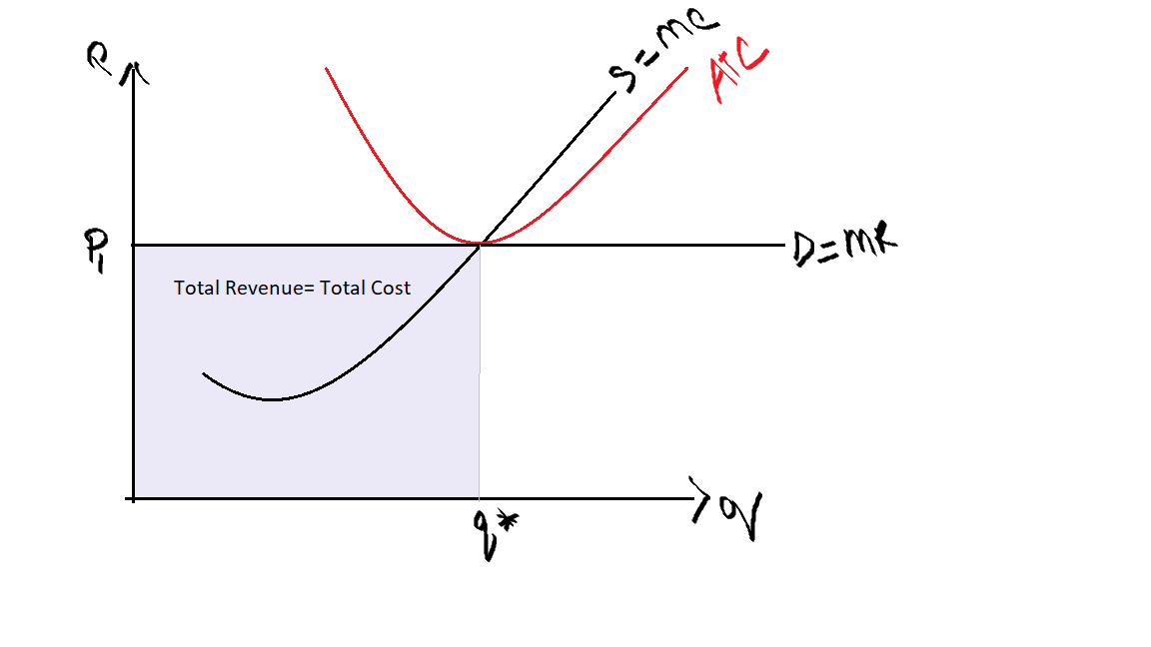

**When price =ATC, the firm is operating at break even point.**

Suppose, the price of good A is reduced to P0 due to some factors (the demand curve shifts downwards), is the firm operating at profit or loss?

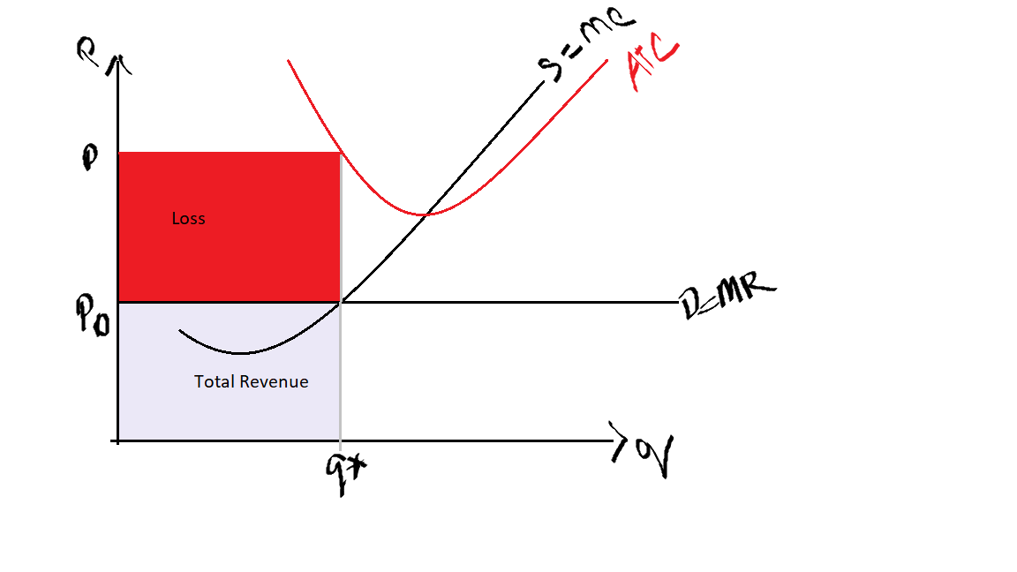

The firm is producing Q*, where MR=MC. At this point, the ATC curve is higher than the price. We can see that the cost of producing Q* units of good A is higher than the revenue earned from selling Q* units of good A, hence the firm incurs a loss.

**When Price or demand is below the ATC curve, firm incurs a loss**

What happens when the price increases to P2? 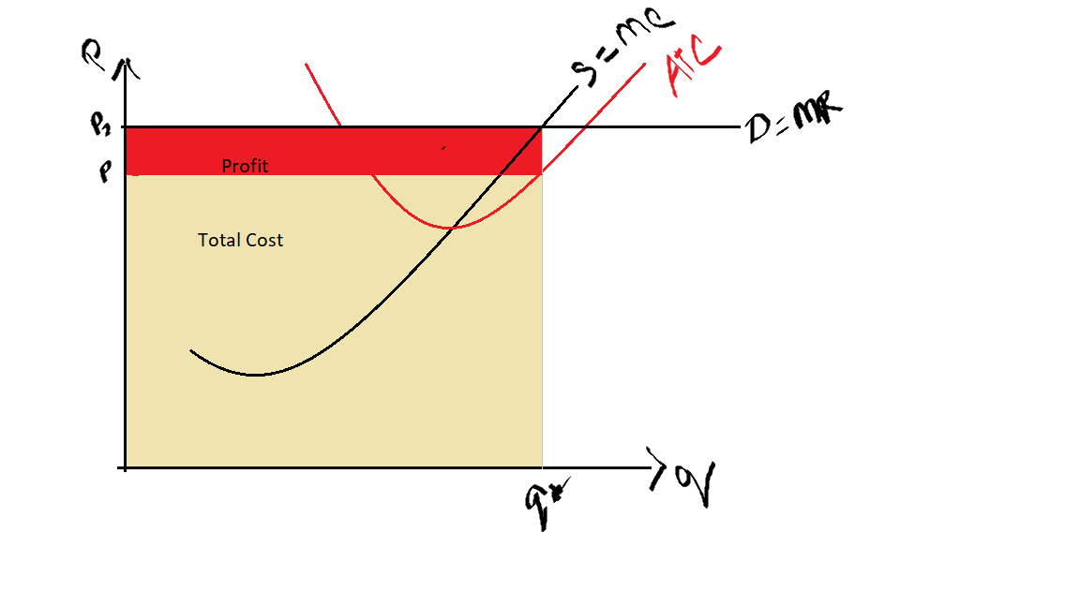

When the price increases such that at the point Q*, the ATC is below the price. Total revenue is higher than total cost. (Total revenue is the sum of area of red rectangles and yellow rectangle). The firm is operating at an economic profit since TR is higher than TC.

**When Price or demand is above the ATC curve, firm incurs a profit.**

**The Firm’s Short-Run Decision to Shut Down**

Even when the firm is operating at a loss when Price/ Demand is below ATC, the firm is still producing, why?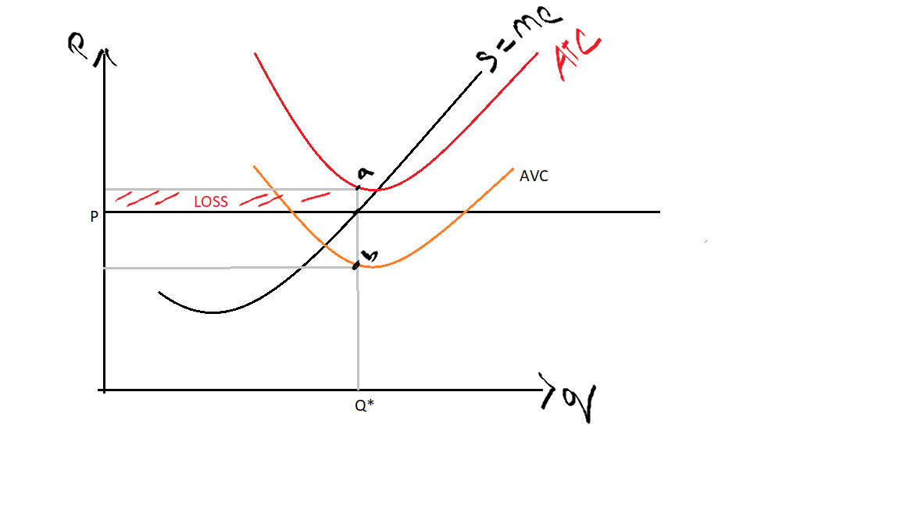

The AVC is below the demand curve so the firm can cover the variable costs and at least some part of fixed costs (difference between ATC - AVC=AFC) hence the firm keeps operating at a loss in the short run.

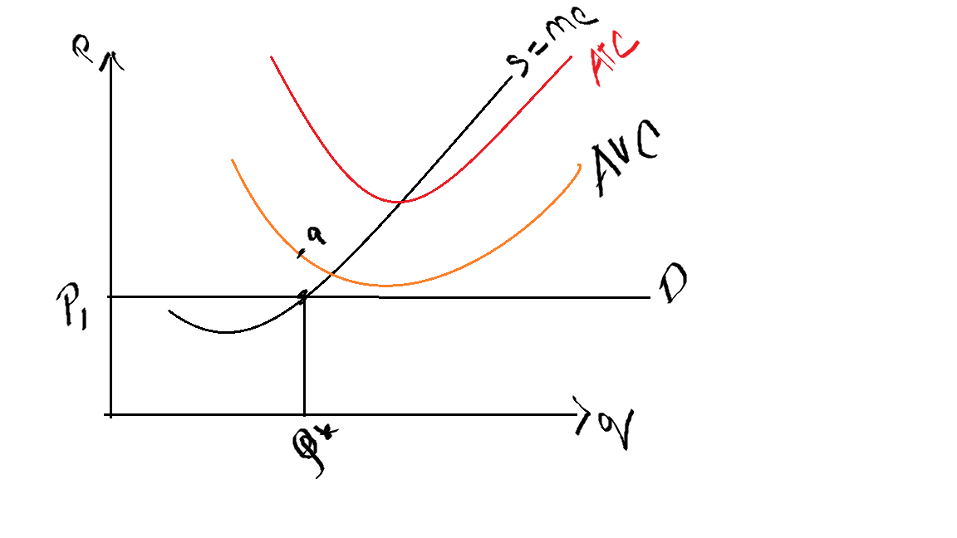

Suppose the price reduces to P1 such that it is below the AVC curve, the firms shut down temporarily because they cannot cover neither the variable costs nor the fixed costs.

Shut Down rule: Shut down if P < AVC

A firm chooses to shut down if the price of the good is less than the average variable cost of production.

**The Firm’s Long-Run Decision to Exit or Enter a Market**

The firm exits if total revenue is less than total cost. By dividing both sides of this inequality by quantity Q, we can write it as

Exit if TR/Q < TC/Q

We can simplify this further by noting that TR/Q is average revenue, which equals the price P, and that TC/Q is average total cost, ATC. Therefore, the firm’s exit rule is

Exit if P <ATC.

That is, a firm chooses to exit if the price of its good is less than the average total cost of production.

How does a firm choose when to enter the market?

Read Chapter 14 from Mankiw